CLUB NEWSLETTER
August - September 2016 Newsletter
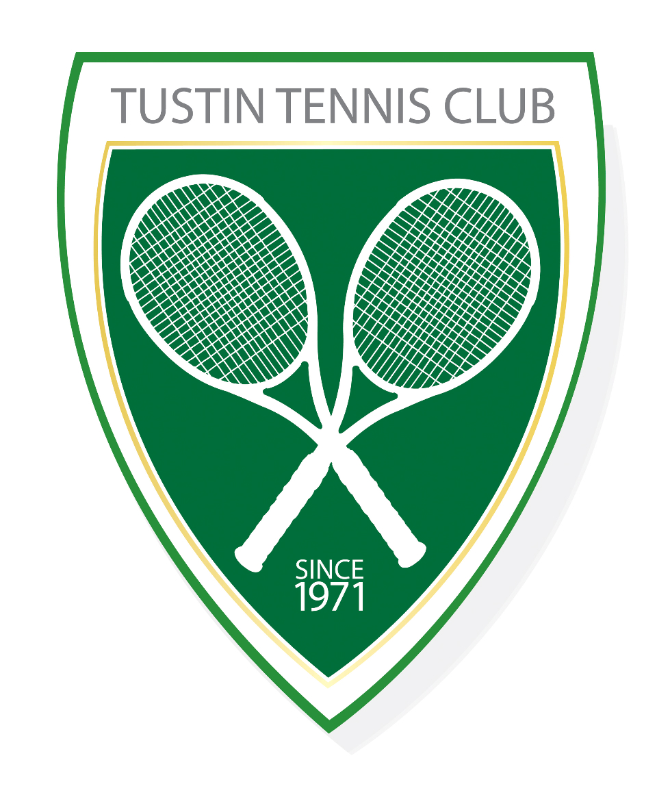
Tustin Tennis Club

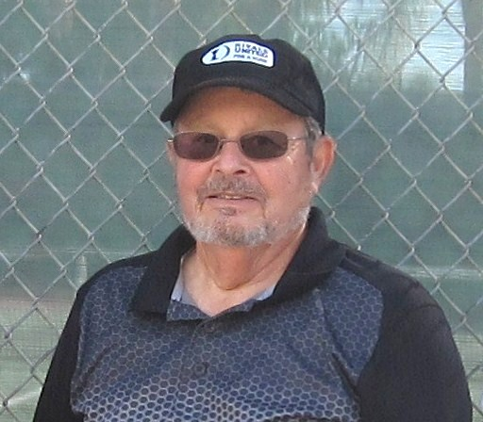
Hello fellow members,
The summer vacation slowdown has started. However, though many people are taking vacations, only the hot July weather reduced the number of players coming for the MWF morning games. We still get all courts playing, but no overcrowding.
Membership renewal is also well underway. Just a reminder, if you haven't renewed by September 1, you are not allowed to play during hours reserved for the club, so get your renewal fees and applications into our membership chair, Allan Gallera.
Our August Board meeting addressed the need to speed up play when we have more than 3, or more, waiting in a single court. While the play rules on the club website haven't been updated yet, the rule changes are included in the meeting minutes. The website will be updated next month. The rules are in effect now.
On another note, several members have had a fall on the courts in the past couple of months, including myself. Fortunately, only one serious injury was sustained. However, these accidents indicated that we aren't really prepared to provide minimal first aid, such as band aids, antiseptic cleansers, etc. I always carry a small kit in my bag. It is a medical kit sold for storage in your car to handle minor needs when on traveling. It would safer if more members carried their own kits at the courts. They are relatively inexpensive.
Finally, to make the newsletter more interesting, we are adding 2 new items to the newsletter. One is a Members page where any member can provide and share an article that could be of interest to the general membership. If you feel you have a general interest article, feel free to compose it and email it to me. Please keep the article, including any photos, to a page or less.
The second item, suggested by Chris Anders, is a tennis quiz. Look for one in this issue. The answer(s) could affect how you score.
That is all for this month. Renew your membership, get your own first aid kit, and see you on the courts.
Stay hydrated.
Neil
President-TTC

Member, USTA

Tennis 4 You Quiz – Subject: Rules
1. If your opponent hits a winner and his/her foot touches the bottom of the net who's point is it?
Nobody's point |  | 1a
Replay the point |  | 1b
Your point |  | 1c
Your opponent's point |  | 1d

2. How many racquets are you allowed to use in 1 match.
3 |  | 2a
4 |  | 2b
5 |  | 2c
As many as it takes |  | 2d

3. Tie-breakers are played at what score in a set?
5-5 |  | 3a
6-6 |  | 3b
6-5 |  | 3c
5-6 |  | 3d

4. If your opponent hits the ball with enough backspin that the ball bounces on your side of the court and then spins back over the net onto their side of the court and you do not touch the ball, whose point is it?
Your opponent's point |  | 4a
Replay the point |  | 4b
Your Point |  | 4d

5. If your opponent wasn't sure if your passing shot was in or out what should happen?
Replay the point |  | 5a
It's their point |  | 5b
Your point |  | 5c
Note: Correct answers for the Tennis 4 U Quiz are shown below at Page 4.

Sundowners League…
League Champions Again – TTC’s Tustin Acers Continue Tradition of Excellence
The Acers had a wonderful season, winning the Sundowners League again! We salute the ladies of the Tustin Acers and Team Captain Debbi Gilson. Deb points out that the Team is very competitive but never forgets the importance of having fun. All Club Members are proud of the accomplishments of this Team and the hard work that was required to get there.

July 4th- Patriotic Players…
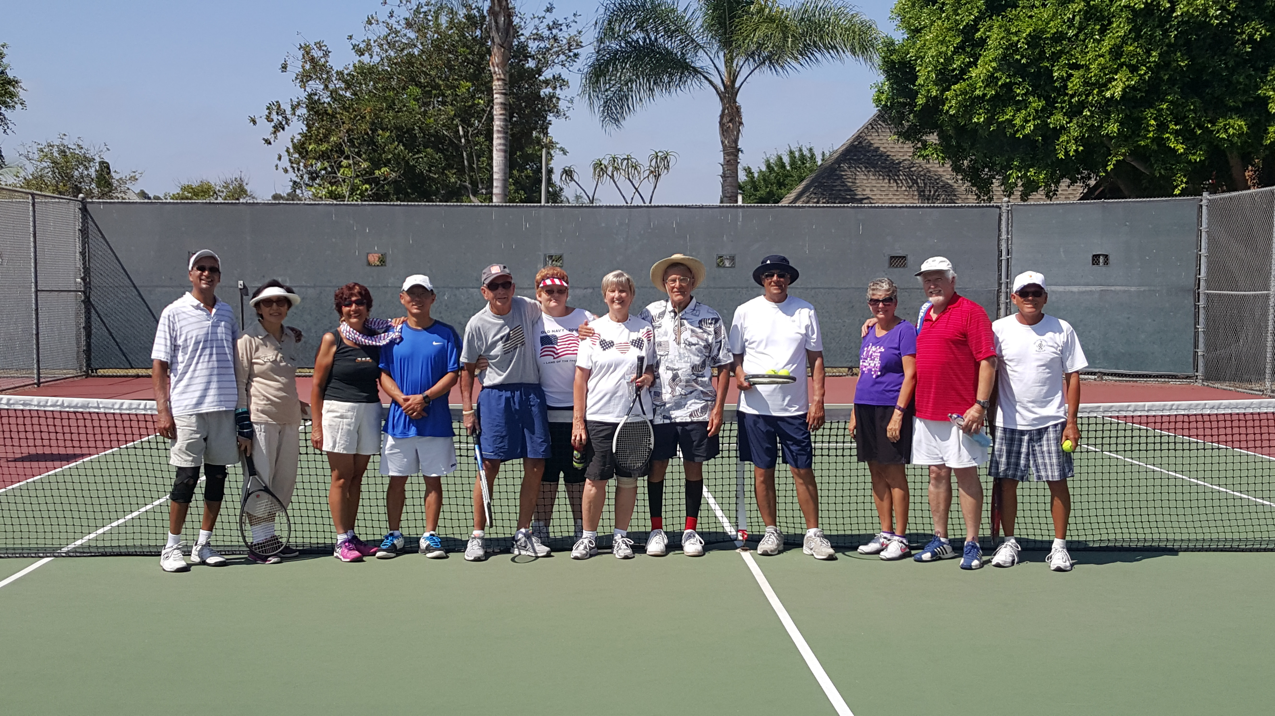

Notes for enjoying the U.S. Open…
This year the Open Tournament runs from August 29 through September 11 in Flushing, Queens, New York. Expectations are high for Serena Williams (who had an “off” summer) and Andy Murray (who had the opposite), along with Rafael Nadal and Stan Wawrinka looking to unseat Novak Djokovic, last year’s champ. Federer will be sitting out the rest of the season with a knee injury.

• NO MORE RAIN DELAYS!!(?)
Construction of the retractable roof over Arthur Ashe Stadium was completed in time for this year’s Open. The roof, which can close in less than 10 minutes, covers the largest tennis stadium in the world. Total cost to build was $150 million, but next year, look for a new 8,000-seat grandstand to open. In 2018, the new Louis Armstrong Stadium will open. Tennis fans don't usually hope for rain, but it will be cool to see this thing in action.

• the gals to watch
Of course, Serena is the most recognizable face in women’s tennis or in tennis, generally. But keep your eye on 22-year-old Monica Puig from Puerto Rico. Ranked 35th in the world, she beat every opponent she faced in this past month's international tournament for the win. She has never advanced past the fourth round of a major tournament, but the experts say that's about to change. She beat Germany's Angelique Kerber in that match.

• THE GUYS TO WATCH.
The names we always hear in men’s tennis are Djokovic, Nadal, and Murray. But now there's Stevie Johnson, who just became the number one player in the U.S. Johnson took over the spot from John Isner who has held that title for 3 years. Isner, in turn, was defeated at the Western & Southern Open by Milos Raonic who made it to the Wimbledon finals earlier this year where he lost to Murray. Raonic’s chances to win are looking good, especially since he’s being coached by none other than the legendary John McEnroe. (We hope McEnroe is teaching him only his good habits.)

Stalwart TTC players braved the heat on the 4th of July this year for some competitive doubles play in celebration of our nation’s Independence. A good time was had by all.

QUIZ ANSWERS… (from Page 2 above)

We hope you did well on the Tennis 4 U Quiz , here are the correct answers.
1. If your opponent hits a winner and his/her foot touches the bottom of the net who's point is it?
Answer: "C" - Your point
2. How many racquets are you allowed to use in 1 match.
Answer: "D" - As many as it takes
3. Tie-breakers are played at what score in a set?
Answer: "B" - 6-6
4. If your opponent hits the ball with enough backspin that the ball bounces on your side of the court and then spins back over the net onto their side of the court and you do not touch the ball, who's point is it?
Answer: "A" - Your opponent's point
5. If your opponent wasn't sure if your passing shot was in or out what should happen?
Answer: "C" - Your point

NOTES FOR ENJOYING the U.S. OPEN...Continued

• the gals to watch.
Of course, Serena is the most recognizable face in women’s tennis. But keep your eye on 22-year-old Monica Puig from Puerto Rico. Ranked 35th in the world, she beat every opponent she faced in this past month's international tournament for the win. She has never advanced past the fourth round of a major tournament, but the experts say that's about to change. She beat Germany's Angelique Kerber in that match.

• THE GUYS TO WATCH.
The names we always hear in men’s tennis are Djokovic, Nadal, and Murray. But now there's Stevie Johnson, who just became the number one player in the U.S. Johnson took over the spot from John Isner who has held that title for 3 years. Isner, in turn, was defeated at the Western & Southern Open by Milos Raonic who made it to the Wimbledon finals earlier this year where he lost to Murray. Raonic’s chances to win are looking good, especially since he’s being coached by none other than the legendary John McEnroe. (We hope McEnroe is teaching him only his good habits, of course in accordance with the requirements of the Rules of Tennis Etiquette of the Tustin Tennis Club.)

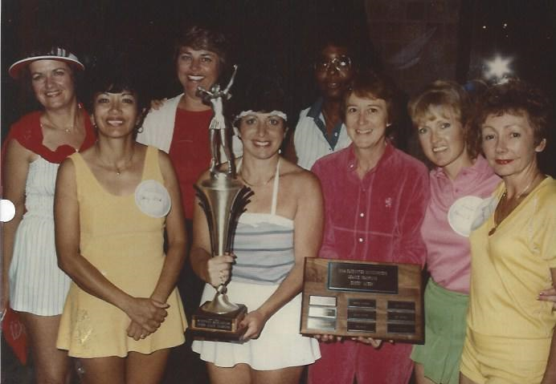
Blast from the Acers Past…
Another Excellent, League-Winning Tustin Acers Team. Can you ID these Players and the Year? Win the photo ID contest and you will receive a modest prize! Send entries to the Club email. Wow, what a big trophy!

Be safe, stay hydrated, send your check for “Membership Month” and always go for the Ace!

